Volunteers Needed at the Beausejour Daylily Gardens
When the display garden began 22 years ago, it was realized very quickly that the 2 acre park was too large for the small group of volunteers to maintain. That’s when the idea of “Garden Angel volunteer program” was initiated. The garden plots were broken down into 10 feet wide sections with numbers displayed from 10 to 60 all along the outer walkway of the gardens. In the centre of this area, we have at least four very large beds that are over 70 feet in diameter. The Kidney bed, the Centre beds which has a north and a south section, and the circle bed. There is also the checkerboard bed, the picnic bed, the parking lot bed, last but not least is the flagpole bed. All of these beds are available for adoption. The idea of a whimsical wooden Garden Angel was developed and still maintained 22 years later. Each wooden angel is hand painted by volunteers, has the volunteer’s name and section # on it.

There are so many benefits when you volunteer at the BDG. Firstly there is the opportunity to learn so much about the vast number of daylily cultivars (we presently have planted over 637), irises (239), lilies(160), peonies(67), ornamental shrubs & trees (86), other perennials (60). Master gardeners are available for any questions you might have.
Volunteering is a great way to connect with others. On April 7 the Friends of the BDG is hosting a Volunteer Appreciation Event for our volunteers. There will be thank you gifts for the volunteers, door prizes, a few presentations, cake and refreshments. Every year we award two of our volunteers a double fan of the Beausejour Angels Reward Daylily. This prestigious daylily is an exclusive to the DLG, and is only given to our volunteers. It is not sold to the general public.
When you volunteer at the BDG you are getting the added benefits of health and well-being. Many studies have proven that time spent with your hands in the soil are very beneficial. Gardening boosts your mood & promotes relaxation. It is known to lower cortisol levels; the soil bacteria can boost production of white blood cells which help fight off infections. On average I have noted that my steps count is averaging 10000 without even trying.
The spring season is the most crucial time to help maintain the BDG. This would be the most time-consuming visit. All the leaves need to be raked off the section as well as last year’s dead growth. If any weeds are obvious at this time they would also need to be dealt with. We supply all of the necessary tools needed to complete the clean up task. Most beds are mulched which helps a lot in decreasing the time spent. I would recommend a visit of once a month to make sure your section is well maintained. A minimum of 2 hours of time should be allotted for your visit. Visits afterwards shouldn’t be more than one hour.
We also have volunteers at large who don’t commit to a section, but will drop in and help us maintain the gardens or help with our many fundraising events, or sit on the Friends of the BDG board.
If you are interested in becoming a volunteer at the BDG email beausejourdaylilygardens@gmail.com or call Lydia @ 204-268-2261.
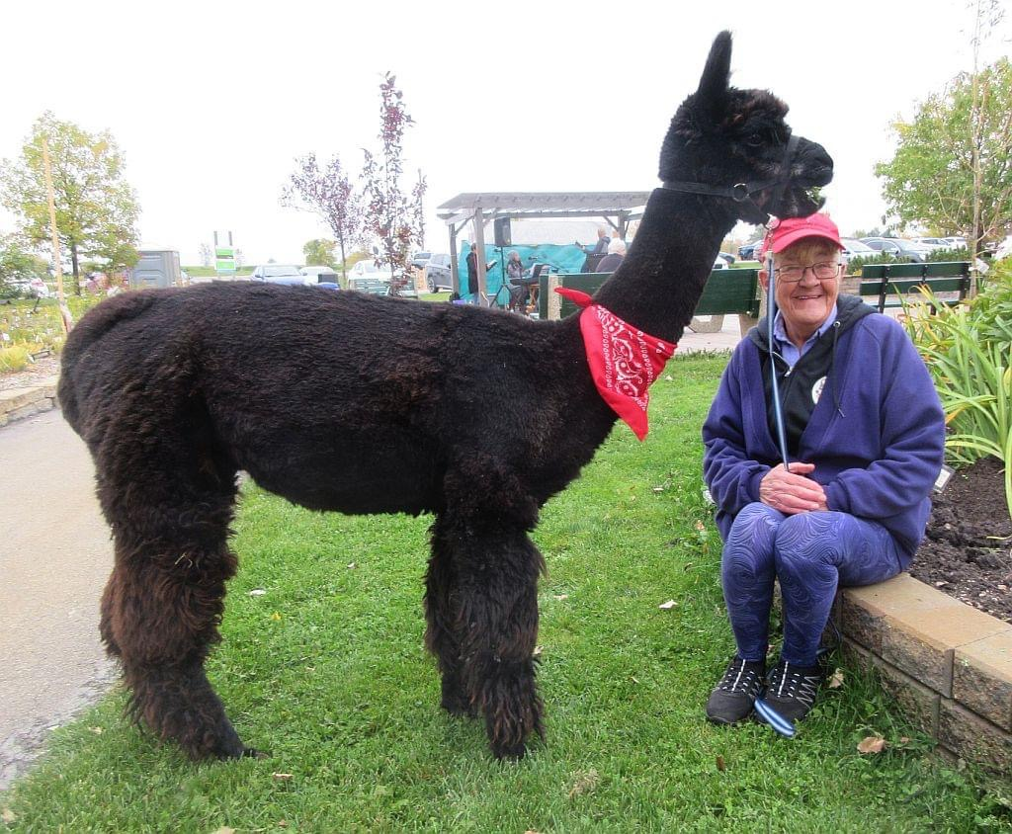
Diane Dumas takes care of the Kidney bed. Annie Alpalca is also a regular volunteer at our Scare Crow Festival event held in October. Diane’s bed is 70 feet long and holds an amazing collection of Lilies, Irises and Daylilies. Her section is a show stopper bed.
Russ Kubera is our volunteer handy man. He also organizes our music concerts events.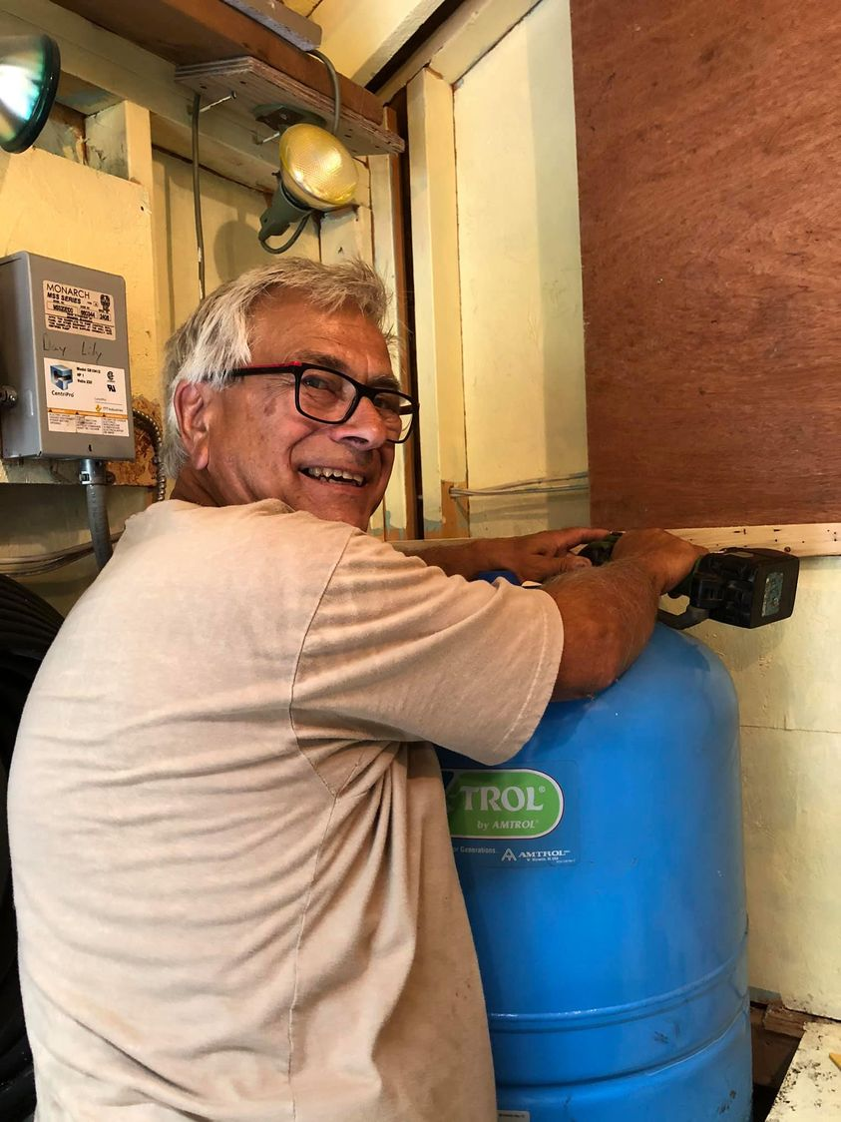
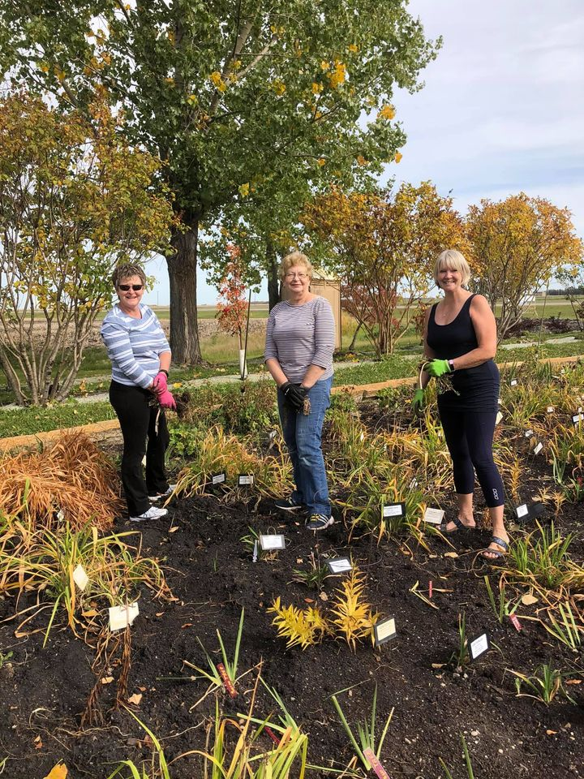
Iris Bialek, Joyce Mellors, and Shaunda Rossington are Garden Angel Volunteers and also sit on the Friends of the BDG committee.

